Verified User sign in
Screen 1: User selects myHMCTS sign in route
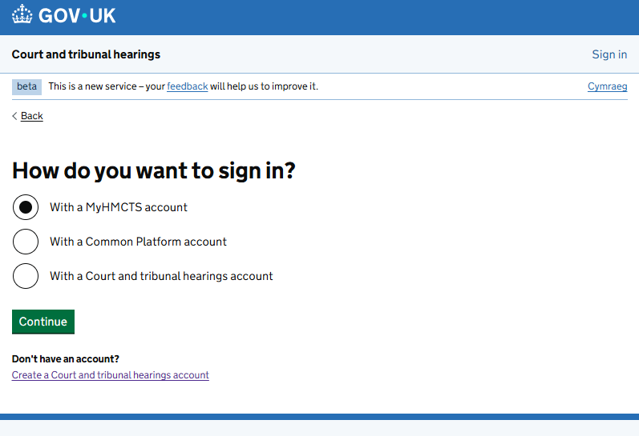

Screen 2: user inputs sign in details
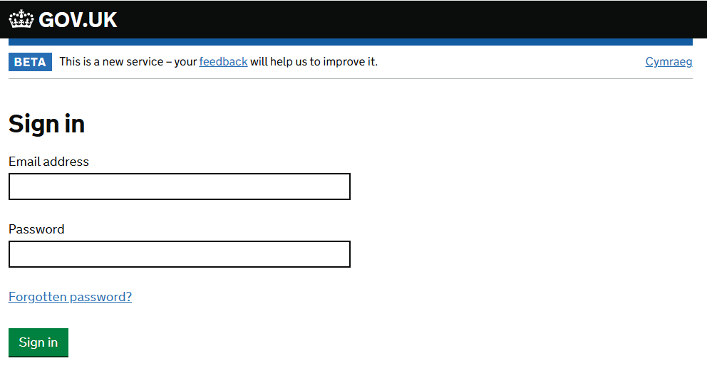

Screen 3: forgotten password
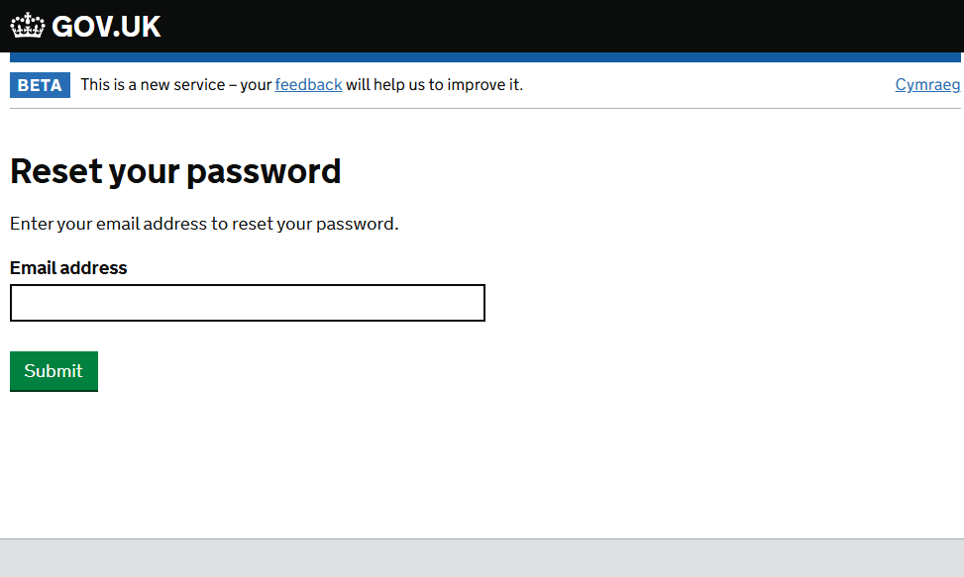

Screen 4: reset password
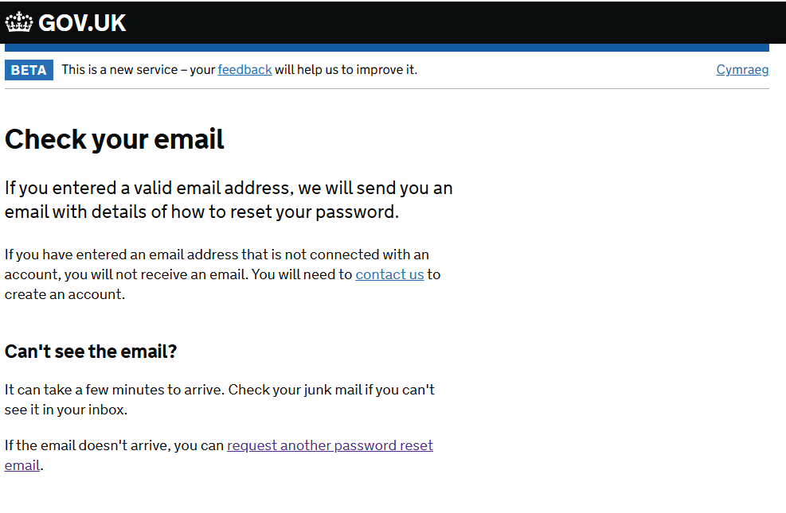

Screen 5: Incorrect sign in details
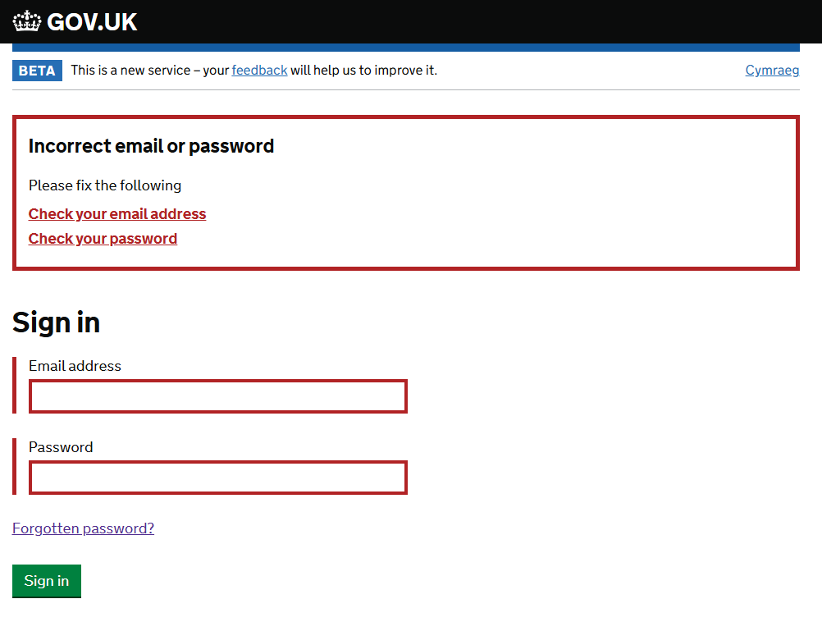

Screen 6: Dashboard
